G VENKATA SRIDHAR  gvsridhar.devops@gmail.com
+91-9739964629

CHEF
What is CHEF?
- Chef is a configuration management technology developed by Opscode to manage infrastructure on physical or virtual machines. It is a automation tool. It provides a way to define infrastructure as code. Infrastructure as code (IAC) simply means that managing infrastructure by writing code (Automating infrastructure) rather than using manual processes. Chef uses pure-Ruby, domain-specific language (DSL)

- Infrastructure configuration
- Application deployment
- Configurations are managed across your network

Why CHEF?
- Chef is a configuration management technology used to automate the infrastructure provisioning.
- Writing reams of documentation sucks. Chef drastically reduces the amount of documentation you have to write.
- Bash does not scale.
- Technical Awesomeness.
- Chef grows with you.
- You can stop reinventing the wheel.
- Your infrastructure literally is code rather than a collection of unique artifacts. Top-level readmes and a few well-placed code comments should be sufficient. Take a look at this recipe for a basic Send-Mail configuration.

CHEF: "IT automation for speed and awesomeness" Chef is a configuration management tool for dealing with machine setup on physical servers, virtual machines and in the cloud. Many companies use Chef Software to control and manage their infrastructure including Facebook, Etsy, Cheezburger and Indiegogo.

- Chef is emerged with many cloud technologies like AWS, Azure and GCE.
- This is the best tool if you have more than 1000 servers
- Difference between chef-apply and chef-solo.
- Chef apply only test the recipe
- Chef-Solo test entire cookbook on locally
- Chef-Solo is an open source version of the chef-client that allows using cookbooks with nodes without requiring access to a Chef server.
- Chef-Solo runs locally and requires that a cookbook (and any of its dependencies) be on the same physical disk as the node.

What is Configuration Management?
  - Configuration management (CM) is a systems engineering process for establishing and maintaining consistency of a product's performance, functional, and physical attributes with its requirements, design, and operational information throughout its life.
  - The configuration management process identifies and tracks the individual CIs, their physical attributes and functional capabilities, and their interdependencies as related to the services they support throughout their operational life. Such information typically includes the versions and updates that have been applied to installed software packages, and the locations and network addresses of hardware devices.
  - A configuration management tool can improve the organization's change-impact analysis, reducing the outages caused by production changes.
  - A configuration management system provides audit and compliance support in historical operational accounting of devices and their utilization and modifications.

Example 1:
- Let us understand Configuration Management this way – suppose you have to deploy a software on top of hundreds of systems. This software can be an operating system or a code or it can be an update of an existing software. You can do this task manually, but what happens if you have to finish this task overnight because tomorrow might be a Big Billion Day sale in the company or some Mega Sale etc. in which heavy traffic is expected. Even if you were able to do this manually, there is a high possibility of multiple errors on your big day. What if the software you updated on hundreds of systems is not working, then how will you revert to the previous stable version, will you be able to do this task manually? AF-course not!
- To solve this problem, Configuration Management was introduced. By using Configuration Management tools like Chef, Puppet, etc. you can automate this task. All you have to do is to specify the configurations in one centralized server and accordingly all the nodes will be configured. It allows access to an accurate historical record of system state for project management and audit purposes. Therefore, we need to specify the configurations once on the central server and replicate that on thousands of nodes. Configuration Management helps in performing the below tasks in a very structured and easy way:

Example 2:
- In your environment 1000 systems available, suppose if you want to update
/etc/hosts file on all machines. This can be done either login to all the machines through SSH and change the host file with your new hostname & IP address. I took lot of time
That is why we found CM, Now the other way is to write some kind of scripts, which updates your file with required data. When the tasks are simple and less time.
The task we can depended on some scripting language like Python, Ruby or even shell scripting.

What is Idempotence?
  - Idempotence arises in a number of places in abstract algebra (in particular, in the theory of projectors and closure operators) and functional programming (in which it is connected to the property of referential transparency).
  - Earlier we can do scripting through update one file to our entire environment, here main drawback is you done one next time can’t do, because file is already exit
  - IN CM 100 times are execute overwrite
Types of CM?
- There are two ways to manage your Configuration namely PUSH and Pull configurations.

Pull Configurations: In this type of configuration management, the nodes poll a centralized server periodically for updates. Those nodes are dynamically configured so they are pulling configuration from the centralized server. Pull configuration is used like Chef, Puppet.

Push Configuration: in this type of configuration management, the centralized server pushes the configurations to the nodes. Unlike pull configuration, there are certain commands that have to be executed in the centralized server in order to configure the nodes. Push configuration is used by tools like Ansible.

Difference between Chef & Puppet?
- Puppet, which has a Master-Slave architecture even Chef, has a Client-Server architecture.
However, Chef has an extra component called Workstation.

Master/Slave: is a model of communication where one device or process has unidirectional control over one or more other devices. In some systems, a master is selected from a group of eligible devices, with the other devices acting in the role of slaves.

Client/Server: architecture (client/server) is a network architecture in which each computer or process on the network is either a client or a server.
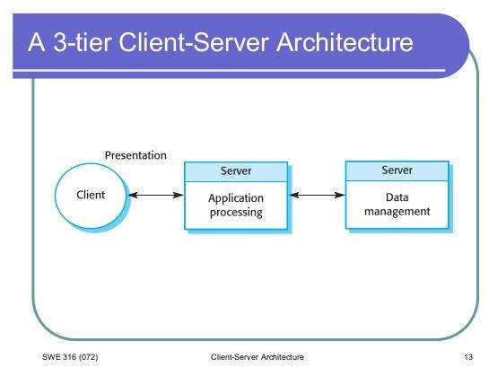
Servers are powerful computers or processes dedicated to managing disk drives (file servers), printers (print servers), or network traffic (network servers). Clients are PCs or workstations on which users run applications. Clients rely on servers for resources, such as files, devices, and even processing power.
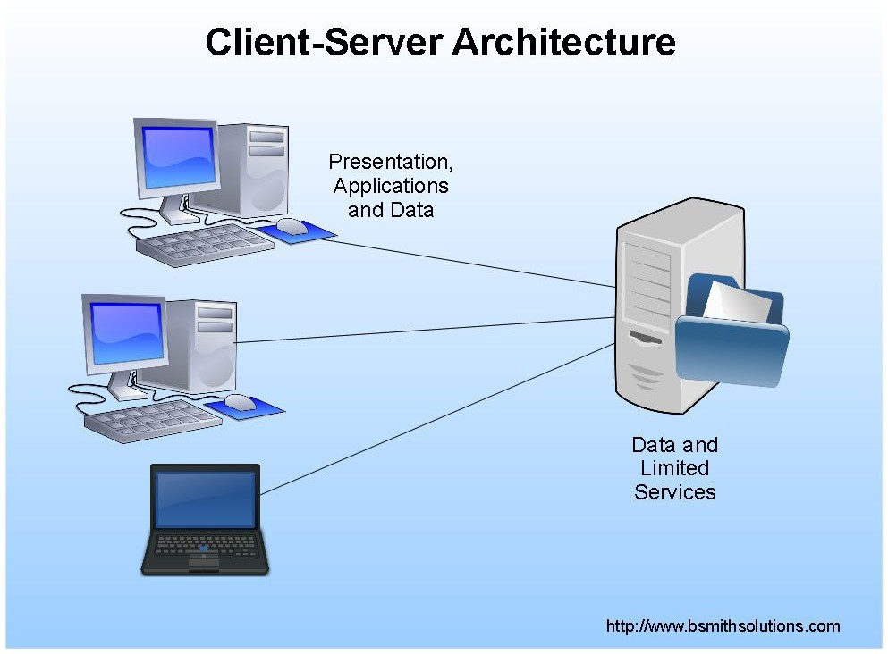

3-Tier Architecture:
- Chef works on 3-tier client server model, a 3-tier client/server is a type of multi-tier computing architecture in which an entire application is distributed across 3-different computing layer or tires.
- It devices the presentation, application & data processing layer across client & server devices.

Presentation Layer:
- This layer mainly translate data between the application layer & network format via different sources. This layer mainly responsible for integrating all formats into a standard format for efficient and effective communication.

Application Layer:
- This one directly interacts with the end user.
- SMTP - Simple Mail Transfer Protocol, File transfer, E-mail client

What is Chef Architecture?
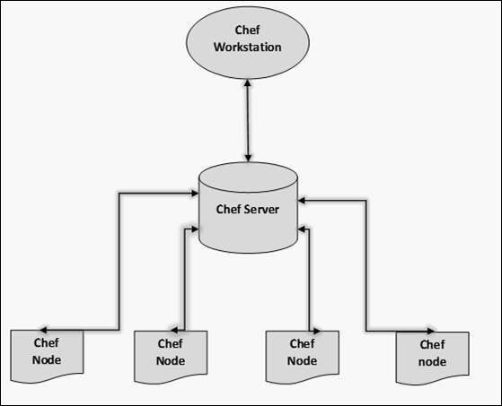

What is Chef Workstation?
  - A workstation is a computer running the Chef Development Kit (ChefDK) that is used to author cookbooks, interact with the Chef server, and interact with nodes
  - Developing and testing cookbooks and recipes
  - Testing Chef Code
  - Configuring organizational policy, including defining roles and environments, and ensuring that critical data is stored in data bags
  - Interacting with nodes, as (or when) required, such as performing a bootstrap operation

What is Chef Development Kit Version : 2.4.17
Chef-Client Version : 13.6.4
Delivery Version : master (73ebb72a6c42b3d2ff5370c476be800fee7e5427)
Berks Version : 6.3.1
Kitchen Version : 1.19.2
Inspect Version : 1.45.13

Step 1: I am create one ce2 instance and logged in that instance
EXIMR-IM-301:Downloads venkateswara.r$ ssh -i AWS_Key_Pair.pem ec2-user@18.220.191.122
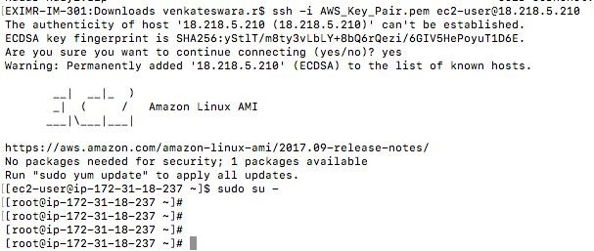

Step 2: Login to chef server
https://manage.chef.io/organizations/venkr890
Go to administration → Click on organization → Check our setting then download Starter Kit

What is Starter Kit?
- If you access to Chef Server hosted or on premises, you can download the Starter kit. The starter kit will create necessary configuration file .chef, directory stored in knife.rb ORGANIZATION-validator.pem and USER.pem simply download the starter kit and then move to the desired location on your workstation.

.chef directory is used to store three files.
  - Knife.rb
  - ORGANIZATION -validator.pem
  - USER.pem

Knife.rb: This configuration file can be downloaded from the organization page.
ORGANIZATION- validator.pem: This is private key can be downloaded from the Organization page.
USER.pem: This is private key can be downloaded from the change password section of the account management page.

- Also located inside the .chef directory are .pem files, which contain private keys, used to authenticate requests made to the Chef server.
- The USERNAME.pem file contains a private key unique to the user (and should never be shared with anyone).
- The ORGANIZATION-validator.pem file contains a private key that is global to the entire organization (and is used by all nodes and workstations that send requests to the Chef server).
- Knife is the [command line interface] (https://docs.chef.io/knife.html) for Chef. The chef-repo contains a .chef directory (which is a hidden directory by default) in which the Knife configuration file (knife.rb) is located. This file contains configuration settings for the chef-repo.
- The knife.rb file is automatically created by the starter kit.
- This file can be customized to support configuration settings used by [cloud provider options](https://docs.chef.io/plugin_knife.html) and custom [knife plugins](https://docs.chef.io/plugin_knife_custom.html).
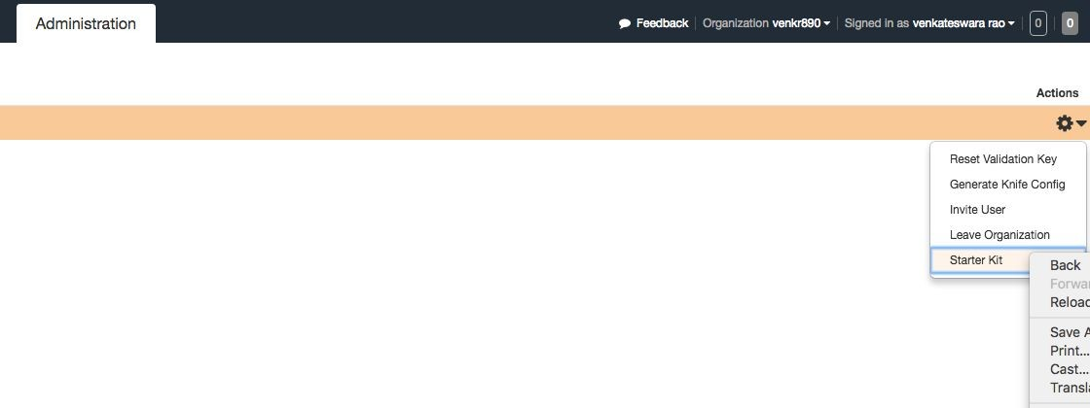
Step 3: Copy starter kit file into our local machine to chef dk machine
EXIMR-IM-301: Downloads venkateswara.r$ scp -i AWS_Key_Pair.pem chef-repo.zip
ec2-user@18.220.191.122:/tmp/
chef-repo.zip
100% 18KB 30.7KB/s 00:00
EXIMR-IM-301: Downloads venkateswara.r$
Step 4: [root@ip-172-31-27-92 tmp] # mkdir /home/chefdk
[root@ip-172-31-27-92 chefdk] # cd/tmp/
[root@ip-172-31-27-92 tmp] # ls chef-repo.zip
[root@ip-172-31-27-92 tmp] # cd chef-repo.zip /root/chefdk/
-bash: cd: chef-repo.zip: Not a directory
[root@ip-172-31-27-92 tmp] # cp chef-repo.zip /root/chefdk/
[root@ip-172-31-27-92 tmp] # cd /root/chefdk/
[root@ip-172-31-27-92 chefdk] # ls chef-repo.zip
[root@ip-172-31-27-92 chefdk]#
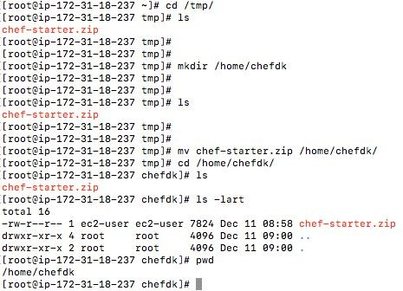
Step 5: [root@ip-172-31-27-92 chefdk] # unzip chef-repo.zip
Archive: chef-repo.zip
creating: chef-repo/
creating: chef-repo/.chef/
inflating: chef-repo/.chef/knife.rb
creating: MACOSX/
[root@ip-172-31-27-92 chefdk] # ls
chef-repo chef-repo.zip MACOSX
[root@ip-172-31-27-92 chefdk] #

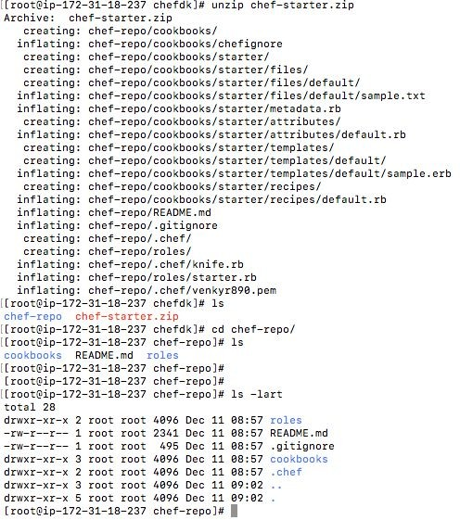

Step 6: This is chefdk download from google
[root@ip-172-31-27-92 chef-repo]# curl -O
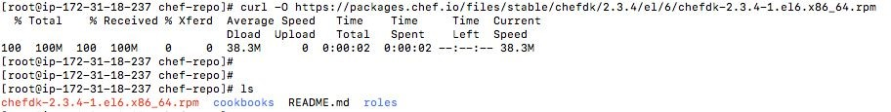
https://packages.chef.io/files/stable/chefdk/2.3.4/el/6/chefdk-2.3.4-1.el6.x86_64.rpm

Step 7: This is Unzip the Downloaded file
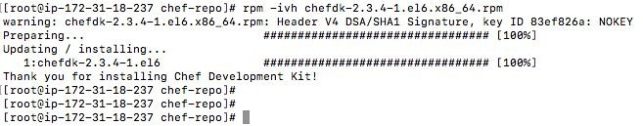
[root@ip-172-31-27-92chef-repo]# rpm -ivh chefdk-2.3.4-1.el6.x86_64.rpm

How to find out ChefDK Version?
- chef -v
- Chef –version

Unzip the starter kit file automatically chef-repo file available

What is chef-repo?
- The chef repository gives structure to organizing all the artifacts (cookbooks, recipes, roles, etc.) that are used with chef to describe and ultimately configure your infrastructure. The repository is needed at development time when you create your own cookbooks, modify existing ones and upload them to your chef server. Think of the repository as a workspace for implementing your infrastructure as code.
- The chef-repo is a directory on your workstation that stores Cookbooks (including recipes, attributes, custom resources, libraries, and templates).
- Roles → Data bags → Environments → metadata.rb
- Every cookbook requires a small amount of metadata. A file named metadata.rb is located at the top of every cookbook directory structure. The contents of the metadata.rb file provides hints to the Chef server to help ensure that cookbooks are deployed to each node correctly.

A metadata.rb file is:
- Located at the top level of a cookbook’s directory structure.
- Compiled whenever a cookbook is uploaded to the Chef server or when the knife cookbook metadatasubcommand is run, and then stored as JSON data.
- Created automatically by knife whenever the knife cookbook create subcommand is run.
- Edited using a text editor, and then re-uploaded to the Chef server as part of a cookbook upload.

Step 1: How to create chef-repo?
[root@ip-172-31-18-237 chefdk]# chef generate repo venkyrepo1

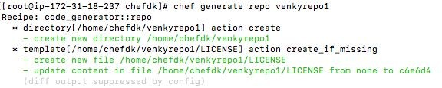

Step 2: You copy the .chef file in chef repo to paste you create in chef-repo
.chef: A hidden directory that is used to store validation key files and optionally a knife.rb file.
A knife.rb file is used to specify configuration details for knife

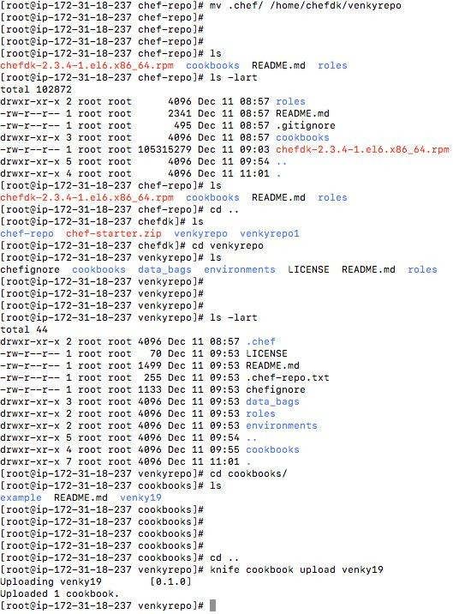
Step 1: How to create cookbook?
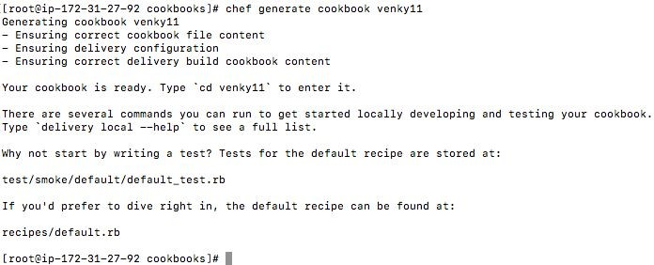

Step 2: How to download cookbook for chef market in google?
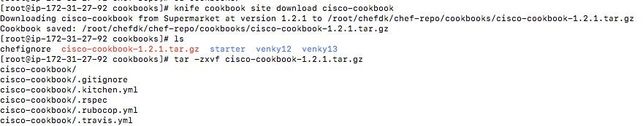
[root@ip-172-31-18-237 cookbooks]# knife cookbook site download httpd

Step 3: How to upload cookbook in chef server?
[root@ip-172-31-18-237 venkyrepo]# knife cookbook upload httpd
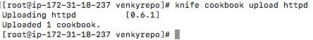

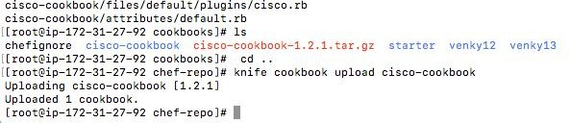

Step 4: How to create cookbook and how to upload cookbook in chef server?
- When you upload the cookbook in chef server, you need to keep in chef-repo path

Why because?
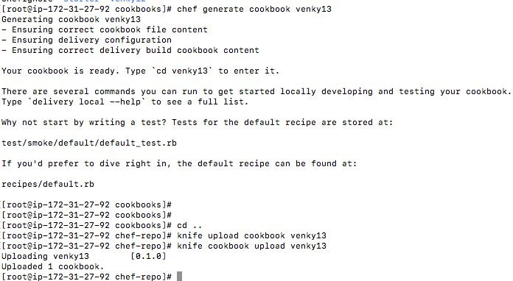
- You ChefDk root directory is chef-repo, here chef server URL’s all are available that’s why

Step 5: How to find how many cookbook in my chef server?

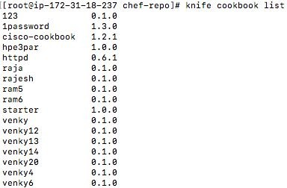
[root@ip-172-31-18-237 chef-repo]# knife cookbook list

Step 6: How to show particular cookbook?
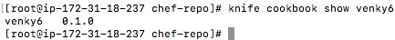
- [root@ip-172-31-18-237 venkyrepo]# knife cookbook show venky6

What is Cookbook?
- A cookbook is the fundamental unit of configuration and policy distribution. A sample cookbook can be found in `cookbooks/starter`. After making changes to any cookbook, you must upload it to the Chef server-using knife:
- Chef maintains a large collection of cookbooks. In addition, there are thousands of cookbooks created and maintained by the community:
- Cookbooks Maintained by Chef - Chef maintains a collection of cookbooks that are widely used by the community.

$ knife upload cookbooks/starter
- A cookbook is a collection of recipes. They are the basic building blocks, which are uploaded to Chef Server.

What is Recipes?
- Recipes that specify the resources to use and the order in which they are to be applied A recipe is the most fundamental configuration element within the organization.
A recipe: Is mostly a collection of resources, defined using patterns (resource names, attribute-value pairs, and actions); helper code is added around this using Ruby, when needed
Recipes are stored in default.rb

What is Resource?
- A resource is a statement of configuration policy that, It is the basic component of a recipe used to manage the infrastructure with different kind of states. There can be multiple resources in a recipe. Describes the desired state for a configuration item

Syntax:
type 'name' do
attribute ‘value’
action :type_of_action
End

For Example:
directory '/tmp/folder' do
owner 'root'
group 'root'
mode '0755'
action :create
End

Example:
[root@ip-172-31-18-237 recipes]# cat default.rb #
# Cookbook:: ram200
# Recipe:: default
# Copyright:: 2017, The Authors, All Rights Reserved.
# recipe:
# package "httpd" do
# action :install
# End

# template "httpd.conf" do
# path "/etc/httpd/conf/httpd.conf" # source "httpd.conf.erb"
# end
# cookbook_file "/var/www/html/index.html" do
# source "index.html"
# End

# service "httpd" do
# action [:start, :enable]
# end
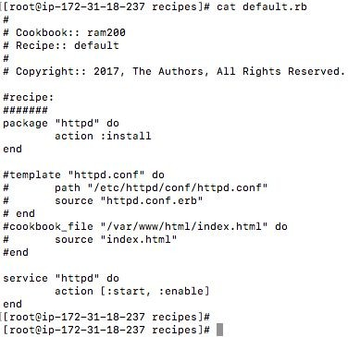
# [root@ip-172-31-18-237 recipes] #

What is Attribute?
- An attribute is a specific detail about a node. Attributes are used by the chef-client to understand: The current state of the node, what the state of the node was at the end of the previous chef-client run,

What the state of the node should be at the end of the current chef-client run.
- An attribute is a specific detail about a node. Attributes are used by the chef-client to understand:
- The current state of the node, what the state of the node was at the end of the previous chef-client run,

What the state of the node should be at the end of the current chef-client run.
- Sometimes you might use hard-coded values (for example, directory name, filename, username, etc.) at multiple locations inside your recipes.
- Later when you want to change this value, it becomes a tedious process,as you have to browse through all the recipes that contains this value and change them accordingly. Instead, you can define the hard-code value as variable inside an attribute file, and use the attribute name inside the recipe.
- This way when you want to change the value, you are changing only at one place in the attribute file.
- These are the different attribute types available: default, force_default, normal, override, force_override, automatic

Syntax:
default['apache']['dir'] = '/etc/apache2'
default['apache']['listen_ports'] = [ '80','443' ]
default['mysql']['dir'] = '/data/mysql'
default['mysql']['username'] = 'dbadmin'
default['mysql']['dbname'] = ‘devdb’

Example:
[root@ip-172-31-18-237 attribute] # cat default.rb default['apache']['Listen'] = '8080'
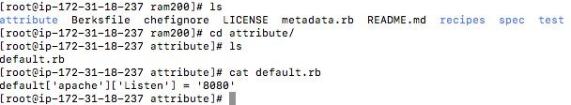
[root@ip-172-31-18-237 attribute] #

What is File?
- It’s a subdirectory within the cookbook that contains any static file which will be placed on the nodes that uses the cookbooks.

What is Berkshelf?
- Berkshelf is a dependency manager for Chef Cookbooks. With it, you can easily depend on community cookbooks and have them safely included in your workflow. You can also ensure that your CI systems reproducibly select the same cookbook versions, and can upload and bundle cookbook dependencies without needing a locally maintained copy. Berkshelf is included in the Chef Development Kit.

What is Library?
- A library file is a Ruby file that is located within a cookbook’s /libraries directory. Because a library is built using Ruby, anything that can be done with Ruby can be done in a library file.

What is Role?
- A role is a way to define certain patterns and processes that exist across nodes in an organization as belonging to a single job function. Each role consists of zero (or more) attributes and a run-list. Each node can have zero (or more) roles assigned to it. When a role is run against a node, the configuration details of that node are compared against the attributes of the role, and then the contents of that role’s run-list are applied to the node’s configuration details. When a chef-client runs, it merges its own attributes and run-lists with those contained within each assigned role.

What is Metadata.rb?
- It is used to manage the metadata about the package. This includes details like the name and details of the package.
- Cookbook_file − Transfers the files from the files subdirectory in the cookbook to a location on the node.
- File − Manages the contents of a file on the node.
- .chef/ - A hidden directory that is used to store validation key files and optionally a knife.rb file.
- environments/ - Stores environment in Ruby (.rb) or JSON (.json).

How to create a chef-repo?
- chef generate repo REPO_NAME

What is Chef Server?
- This works as a centralized working unit of Chef setup, where all the configuration files are uploaded post development. The Chef server is the primary mode of communication between the workstations where your infrastructure is coded, and the nodes where it is deployed. All configuration files, cookbooks, metadata, and other information are stored on the server. The Chef server also keeps information regarding the state of all nodes at the time of the last chef-client run.
- There are different kinds of Chef server, some are hosted Chef server whereas some are built-in premise.

Hosted Chef Server:
- Opscode, the makers of Chef, provide a service called Hosted Chef which is a Chef Server as a service. They offer a free tier which is good for 5 nodes so is ideal to help us get started.
- Launch package: $120/month, 20 nodes, 10 users
- Standard package: $300/month, 50 nodes, 20 user

On Premises (Private) Chef
- With On Premises Chef, a Chef server to be run on-premises is provisioned by the customer. The main advantage over Hosted Chef, of course, is that full control over the server is maintained. Faster rollout and better integration is also possible since the server is likely to be physically closer to the rest of the customer’s network. And because On Premises Chef servers reside behind the customer’s own firewalls, the machines are shielded from any public global issues that may affect Hosted Chef customers.

What is Firewall?
- A firewall is a network security system that monitors and controls incoming and outgoing network traffic based on predetermined security rules. Firewalls are often categorized as either network firewalls or host-based firewalls. Network firewalls filter traffic between two or more networks and run on network hardware. Host-based firewalls run on host computers and control network traffic in and out of those machines.

Uses of Firewall:
A Firewall Protects Your Computer from Unauthorized Remote Access
- One of the worst things that could happen to your computer is if someone attempts to take control remotely. Seeing the mouse move around on your monitor as a remote intruder usurps your digital kingdom, assuming control of your data, is petrifying.
- With a correctly configured firewall (and a modern OS) you should have remote desktop access disabled, thus preventing hackers from taking over your computer.

You Can Block Unsuitable or Immoral Content with a Firewall
- We have been talking mainly about blocking hackers and various types of remote access malware so far, but firewalls are capable of more than this. As well as protecting personal directories from ransomware, firewall applications might also feature the option to block particular online locations.

What is Reports?
- Use Reporting to keep track of what happens during the execution of chef-client runs across all of the machines that are under management by Chef. Reports can be generated for the entire organization and they can be generated for specific nodes.
- Reporting data is collected during the chef-client run and the results are posted to the Chef server at the end of the chef-client run at the same time the node object is uploaded to the Chef server.

What is Node?
- The name of a node is required as part of the authentication process to the Chef server. The name of each node must be unique within an organization.

What is Policy?
- Policy maps business and operational requirements, process, and workflow to settings and objects stored on the Chef server

What is Cookbook?
- A cookbook version represents a set of functionality that is different from the cookbook on which it is based.
- A cookbook version is maintained just like a cookbook, with regard to source control, uploading it to the Chef server, and how the chef-client applies that cookbook when configuring nodes.
- Roles define server types, such as “web server” or “database server” Environments define process, such as “dev”, “staging”, or “production”

What is Data Bags?
- A data bag is a global variable that is stored as JSON data and is accessible from a Chef server. A data bag is indexed for searching and can be loaded by a recipe or accessed during a search.

Create Bags:
- A data bag can be created in two ways: using knife or manually. In general, using knife to create data bags is recommended, but as long as the data bag folders and data bag item JSON files are created correctly, either method is safe and effective.

How to create a data bag?
- Knife data bag create Data_Bag_Name (Data_Bag_Item)
- Knife can be used to update data bag items using the from file argument:
- $ knife data bag from file BAG_NAME ITEM_NAME.json
- One or more data bags and data bag items can be created manually under the data_bags directory in the chef-repo. Any method can be used to create the data bag folders and data bag item JSON files.
Example: $ mkdir data_bags/admins
Would create a data bag folder named “admins”. The equivalent command for using knife is:
$ knife data bag create admins
List of data bags: Knife data bag list

What is Environment?
- An environment is a way to map an organization’s real-life workflow to what can be configured and managed when using Chef Server. Every organization begins with a single environment called the _default environment, which cannot be modified (or deleted). Additional environments can be created to reflect each organization’s patterns and workflow. For example, creating production, staging, testing, and development environments. Generally, an environment is also associated with one (or more) cookbook versions.
What is _default?
- Every organization must have at least one environment. Every organization starts out with a single environment that is named _default, which ensures that at least one environment is always available to the Chef server. The _default environment cannot be modified in any way. Nodes, roles, run-lists, cookbooks (and cookbook versions), and attributes specific to an organization can only be associated with a custom environment.

What is Role?
- A role is a way to define certain patterns and processes that exist across nodes in an organization as belonging to a single job function. Each role consists of zero (or more) attributes and a run-list. Each node can have zero (or more) roles assigned to it. When a role is run against a node, the configuration details of that node are compared against the attributes of the role, and then the contents of that role’s run-list are applied to the node’s configuration details. When a chef-client runs, it merges its own attributes and run-lists with those contained within each assigned role.

What is Chef Clients?
- A chef-client is an agent that runs locally on every node that is under management by Chef. When a chef-client is run, it will perform all of the steps that are required to bring the node into the expected state, including
- Registering and authenticating the node with the Chef server
- RSA public key-pairs are used to authenticate the chef-client with the Chef server every time a chef-client needs access to data that is stored on the Chef server. This prevents any node from accessing data that it should not and it ensures that only nodes that are properly registered with the Chef server can be managed.

What is run-list?
- A run-list defines all of the information necessary for Chef to configure a node into the desired state. A run-list is:
- An ordered list of roles and/or recipes that are run in the exact order defined in the run-list; if a recipe appears more than once in the run-list, the chef-client will not run it twice.
- Always specific to the node on which it runs; nodes may have a run-list that is identical to the run-list used by other nodes.
- Stored as part of the node object on the Chef server.
- Maintained using knife and then uploaded from the workstation to the Chef server, or maintained using Chef Automat

What is Node & Setup?
- A node is any machine—physical, virtual, cloud, network device, etc.—that is under management by Chef

EXIMR-IM-301:Downloads venkateswara.r$ ssh -i AWS_Key_Pair.pem
ec2-user@18.217.164.193
[ec2-user@ip-172-31-34-42 ~]$ sudo su –
[root@ip-172-31-34-42 ~]# mkdir /etc/chef
[root@ip-172-31-34-42 ~]# touch hello.pem
[root@ip-172-31-34-42 ~]# ls
Hello.pem
[root@ip-172-31-34-42 chef]# vi client.rb
[root@ip-172-31-34-42 chef]# cat client.rb
log_level :info
log_location STDOUT
ssl_verify_mode :verify_none
node_name "ram10"
chef_server_url "https://manage.chef.io/organizations/venkr890"
validation_client_name "hello"
validation_key "/etc/chef/hello.pem"
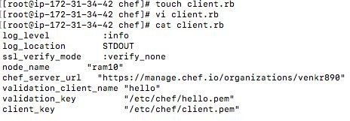
client_key "/etc/chef/client.pem"

[root@ip-172-31-32-65 chefnode]# curl -O
https://packages.chef.io/files/stable/chef/13.6.4/el/7/chef-13.6.4-1.el7.x86_64.rpm
[root@ip-172-31-32-65 chefnode]# rpm -ivh chef-13.6.4-1.el7.x86_64.rpm

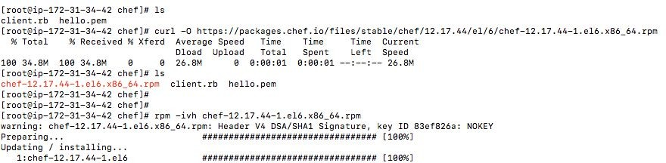

When cookbook is placed in node how to run?
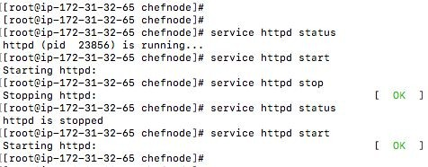
[root@ip-172-31-32-65 chefnode]# chef-client

How to find out node list - knife node list
You can also use knife node to delete nodes - knife node delete frontend01
Or, show more detailed node attributes - knife node show frontend01
You can get a full listing of your node's attributes using the -l option - knife node show -l frontend01

What is client.rb file in Chef Server?
- A client.rb file is used to specify the configuration details for the chef-client
- On UNIX- and Linux-based machines, the default location for this file is /etc/chef/client.rb;
- On Microsoft Windows machines, the default location for this file is C:\chef\client.rb;
- This file is not created by default

Where we got the hello.pem file?
- By default login to chef server -- https://manage.chef.io/organizations/venkr890
- Goto Administration → Click on organization → Reset validation key → Copy or Download that content

How to connect chef-client to chef server?
- Chef-client
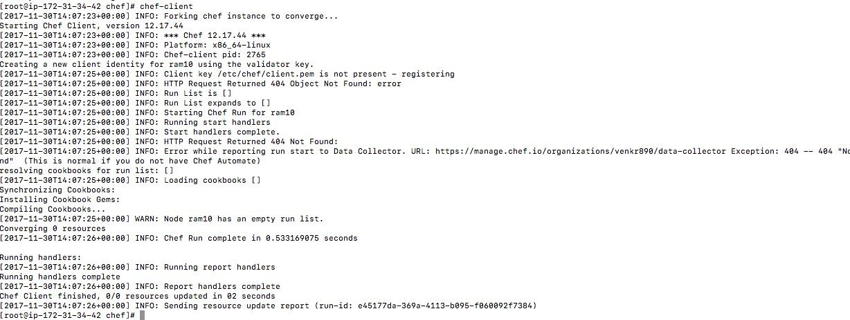
What is OHAI?
- OHAI is a tool that is used to collect system configuration data, which is provided to the chef-client for use within cookbooks. OHAI is run by the chef-client at the beginning of every Chef run to determine system state.

The types of attributes OHAI Collects:
- Operating System, Network, Memory, Disk, CPU, Kernel, Host names, fully qualified domain Names.

What is Bootstrap a Node?
- A node is any physical, virtual, or cloud machine that is configured to be maintained by a chef-client. In order to bootstrap a node, you will first need a working installation of the Chef Software package. A bootstrap is a process that installs the chef-client on a target system so that it can run as a chef-client and communicate with a Chef server.
- Command - knife bootstrap 172.31.40.232 --ssh-user ec2-user --sudo --identity-file
/home/ec2-user/AWS_Key_Pair.pem --node-name Ram-node11

Two Types:
- Use the knife bootstrap subcommand to bootstrap a node using the omnibus installer.
- Use an unattended install to bootstrap a node from itself, without using SSH or WinRM
1st - you need to connect chef dk machine
Here you place the hello.pem file & client.rb file in /etc/chef folder
log_level :info
log_location STDOUT
ssl_verify_mode :verify_none
#node_name "ram10"
chef_server_url https://manage.chef.io/organizations/venkr890
validation_client_name "val"
validation_key "/etc/chef/validator.pem"
client_key "/etc/chef/client.pem"
